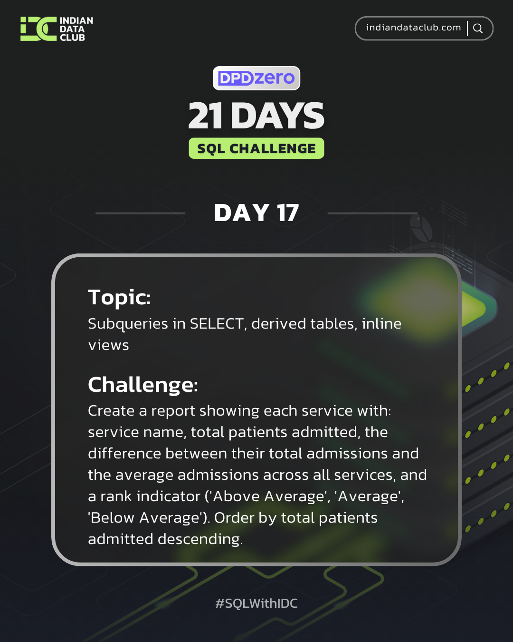
Day-17 SQL Challenge
Day-17 Challenge:
Create a report showing each service with: service name, total patients admitted, the difference between their total admissions and the average admissions across all services, and a rank indicator ('Above Average', 'Average', 'Below Average'). Order by total patients admitted descending.
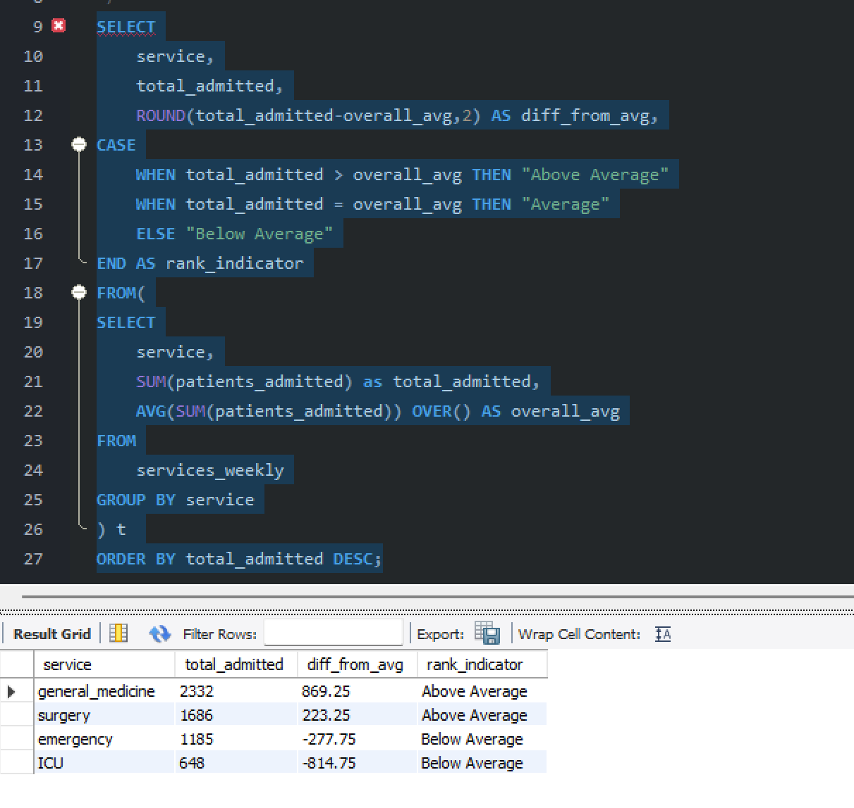

Practice Questions:
1. Show each patient with their service's average satisfaction as an additional column.
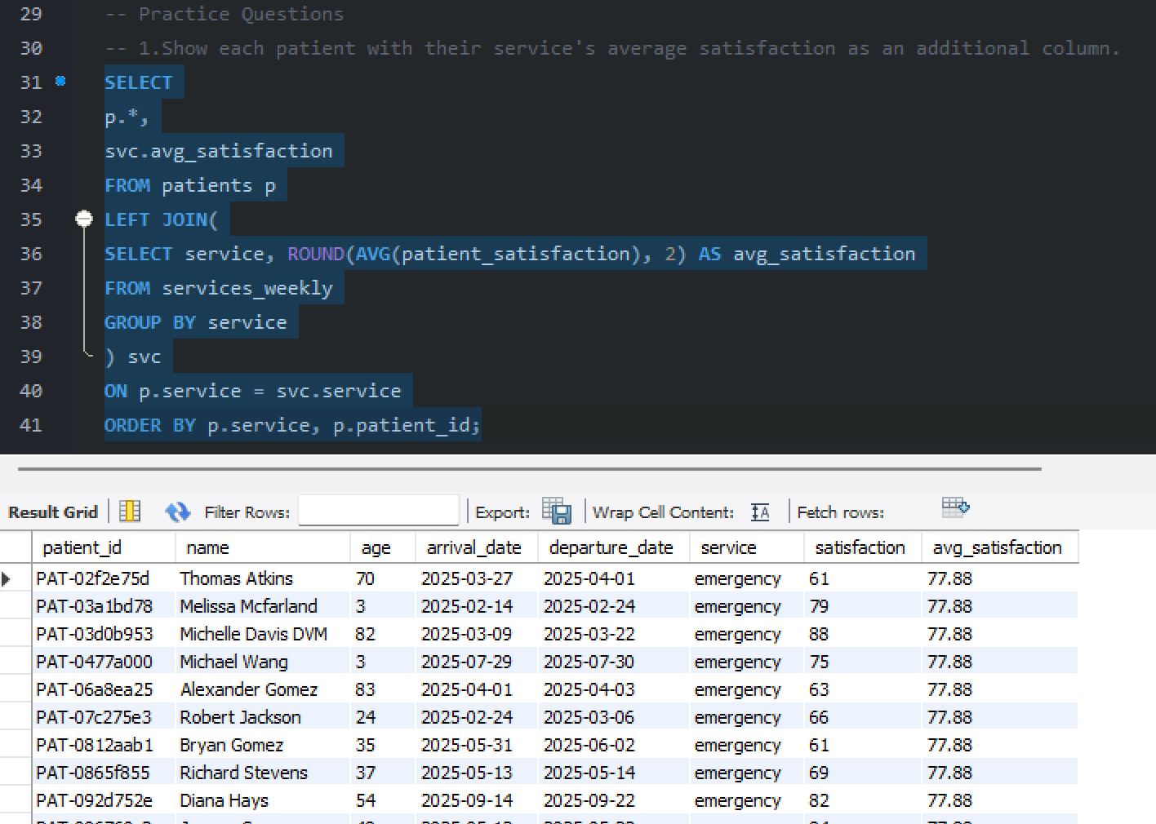

2. Create a derived table of service statistics and query from it.
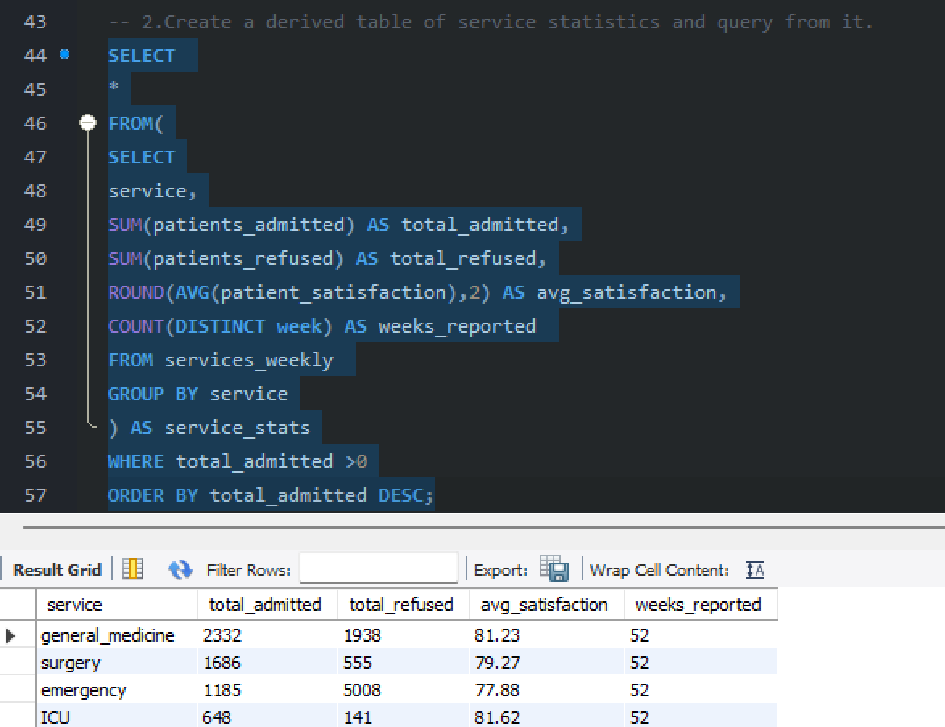
3. Display staff with their service's total patient count as a calculated field.
